Kubernetes 05
- Create a namespace dev-environment and apply a resource-based quota that restricts the number of pods to 3 and services to 2.
Create dev-environment namespace and apply a ResourceQuota
Restrict:
Pods → 3
Services → 2

Step 1: Create Namespace
kubectl create namespace dev-environment
Validate
kubectl get ns
You should see:
dev-environment
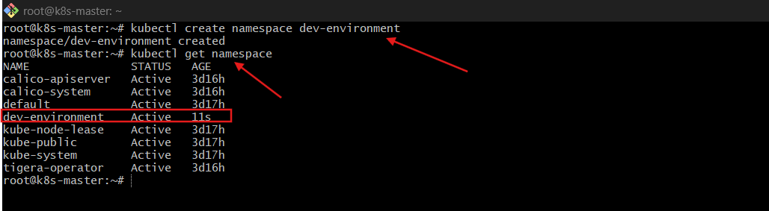
Step 2: Create ResourceQuota
Create quota.yaml:
vi quota.yaml
apiVersion: v1
kind: ResourceQuota
metadata:
name: dev-quota
namespace: dev-environment
spec:
hard:
pods: "3"
services: "2"
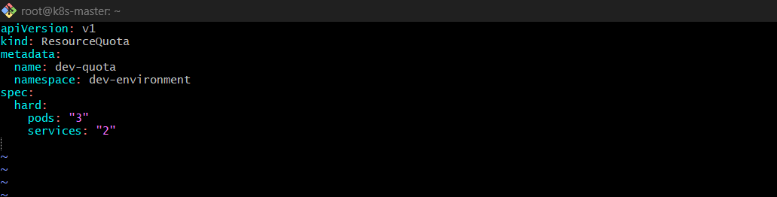
Apply it:
kubectl apply -f quota.yaml
Validation
Check quota:
kubectl describe quota dev-quota -n dev-environment
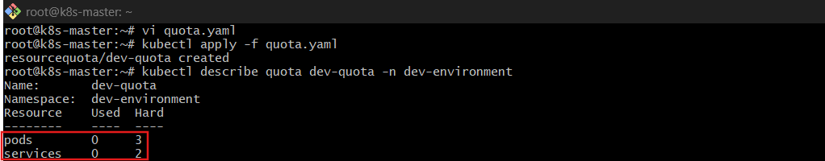
Try creating 4 pods:
kubectl run pod1 --image=nginx -n dev-environment
kubectl run pod2 --image=nginx -n dev-environment
kubectl run pod3 --image=nginx -n dev-environment
kubectl run pod4 --image=nginx -n dev-environment
The 4th pod should fail.
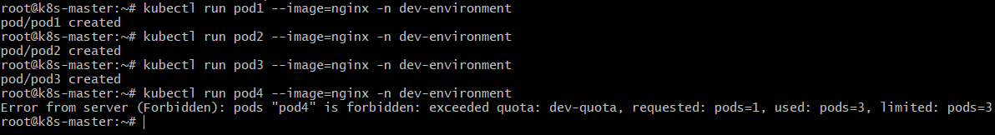
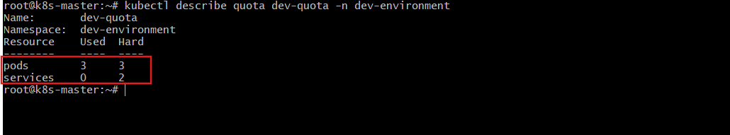
Explanation
ResourceQuota enforces a hard limit at namespace level.
The API server rejects new resources once limits are reached.

- Create a pod in the prod-environment namespace with 0.2 CPU and 200Mi memory requests, and 0.5 CPU and 500Mi memory limits.
Create Pod in prod-environment with resource requests & limits
Requirements:
- Requests: 200m CPU, 200Mi memory
- Limits: 500m CPU, 500Mi memory

Step 1: Create Namespace
kubectl create namespace prod-environment
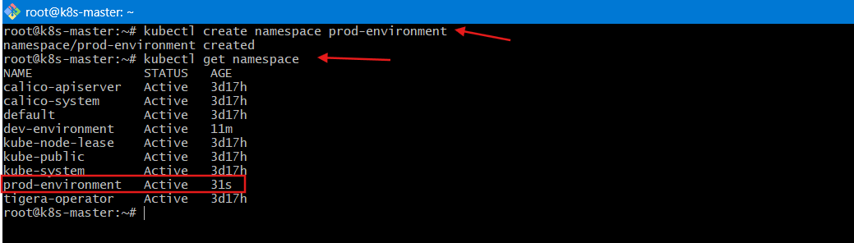
Step 2: Create Pod YAML
vi prod-pod.yaml
apiVersion: v1
kind: Pod
metadata:
name: prod-pod
namespace: prod-environment
spec:
containers:
- name: nginx
image: nginx
resources:
requests:
cpu: "200m"
memory: "200Mi"
limits:
cpu: "500m"
memory: "500Mi"
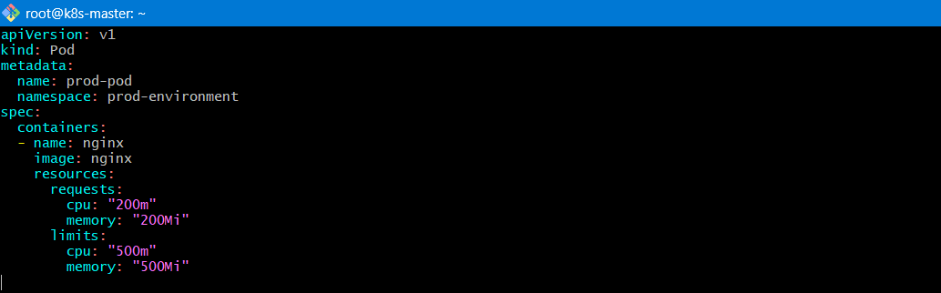
Apply:
kubectl apply -f prod-pod.yaml
Validation
kubectl describe pod prod-pod -n prod-environment
Look under:
Limits:
cpu: 500m
memory: 500Mi
Requests:
cpu: 200m
memory: 200Mi
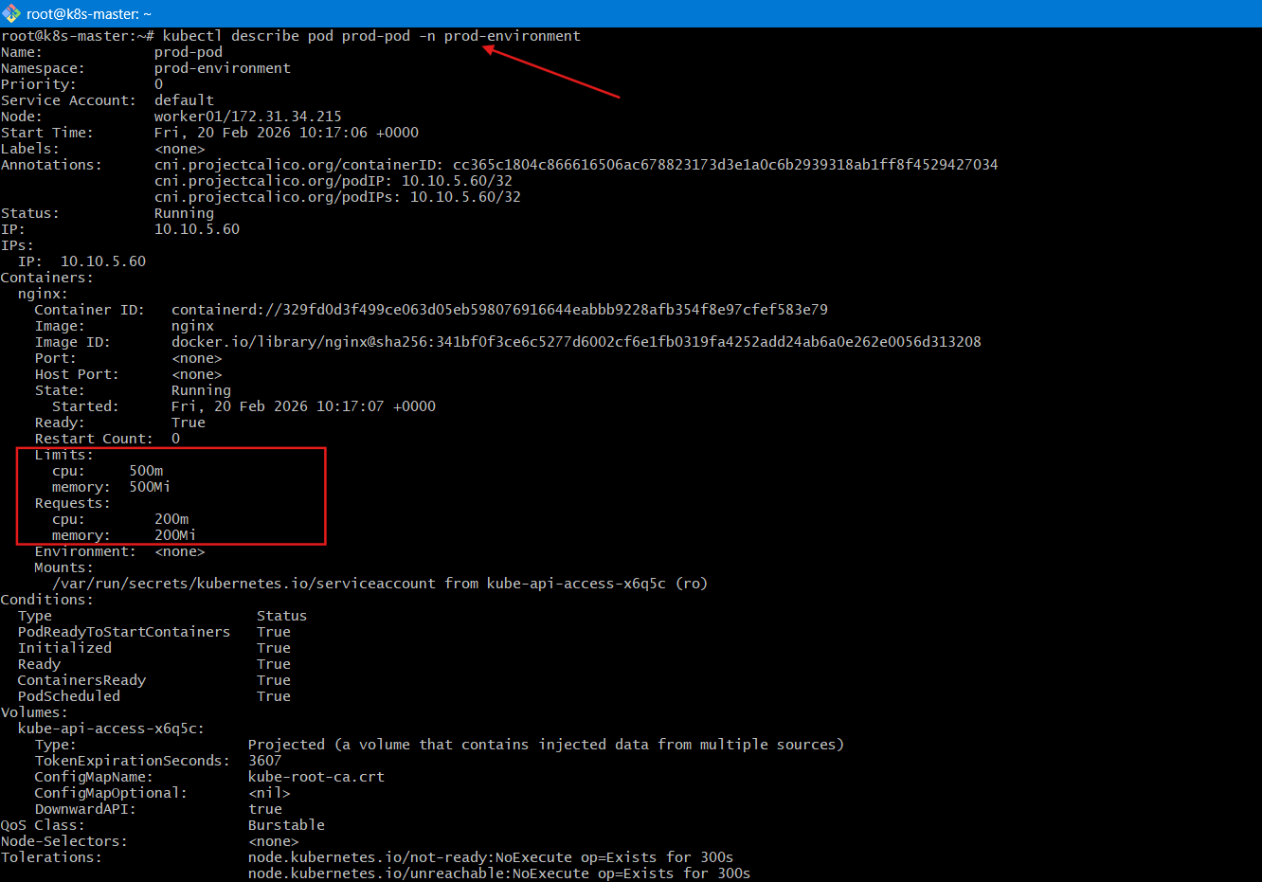

Explanation
Requests → Used by scheduler to place pod.
Limits → Enforced by kubelet.
- CPU → throttled if exceeded.
- Memory → container killed (OOM) if exceeded.

- In the staging-environment namespace, set a LimitRange that assigns default CPU and memory limits (300m CPU, 600Mi memory) and applies a minimum and maximum CPU.
Create LimitRange in staging-environment
Requirements:
- Default limits: 300m CPU, 600Mi memory
- Set min and max CPU

Step 1: Create Namespace
kubectl create namespace staging-environment
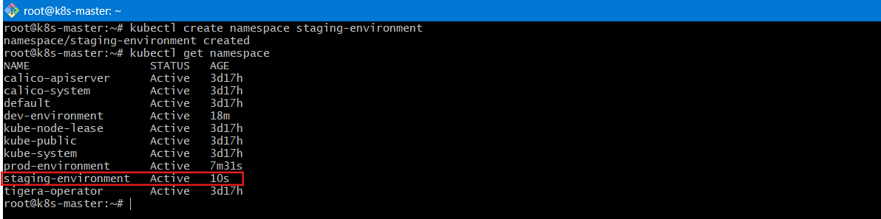
Step 2: Create LimitRange YAML
vi limitrange.yaml
apiVersion: v1
kind: LimitRange
metadata:
name: staging-limits
namespace: staging-environment
spec:
limits:
- type: Container
default:
cpu: 300m
memory: 600Mi
defaultRequest:
cpu: 200m
memory: 300Mi
min:
cpu: 100m
max:
cpu: 800m
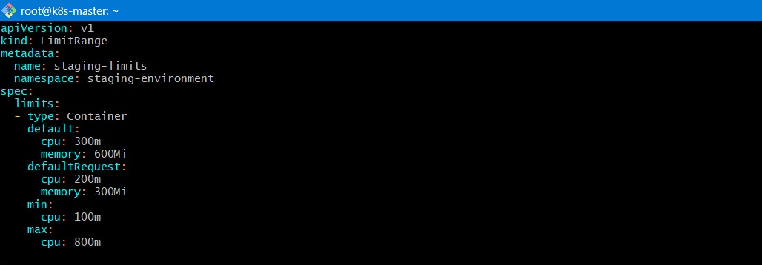
Apply:
kubectl apply -f limitrange.yaml
Validation
Create pod without resources:
kubectl run testpod --image=nginx -n staging-environment
Check:
kubectl describe pod testpod -n staging-environment
You will see default limits automatically applied.
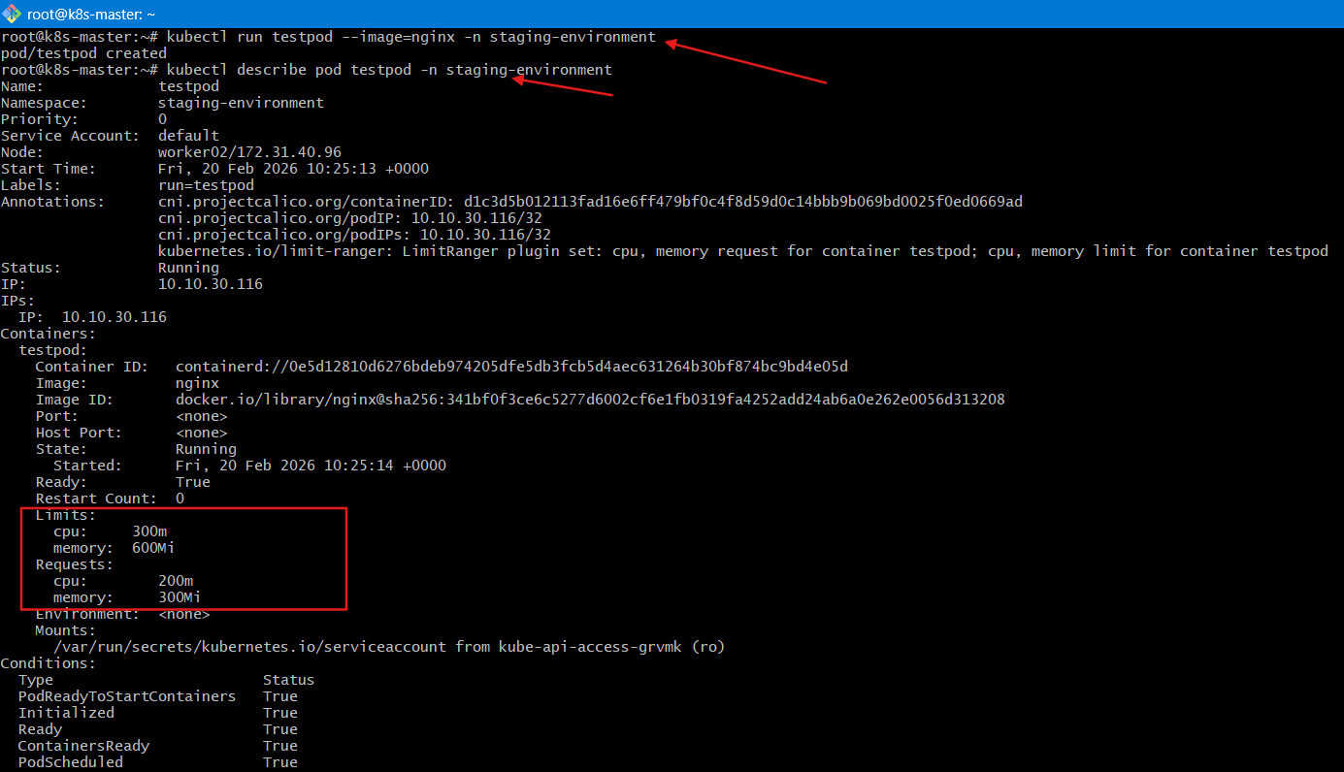

Explanation
LimitRange:
- Applies default values if not specified
- Enforces min/max constraints
- Prevents resource abuse inside namespace

- Create a pod and a NodePort service in the default namespace, then create another pod in the test namespace and communicate between them using Service DNS.
Pod + NodePort Service in default namespace
Then communicate from another namespace using DNS

Step 1: Create Pod in default namespace
kubectl run webpod --image=nginx
Step 2: Expose as NodePort
kubectl expose pod webpod --type=NodePort --port=80
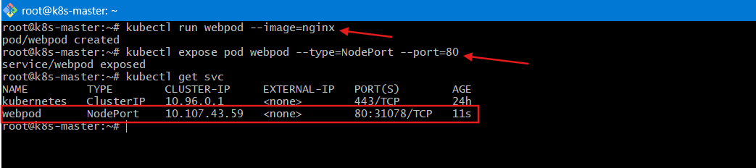
Validate
kubectl get svc
You’ll see a NodePort (e.g., 30007)
Access:
http://<NodeIP>:<NodePort>
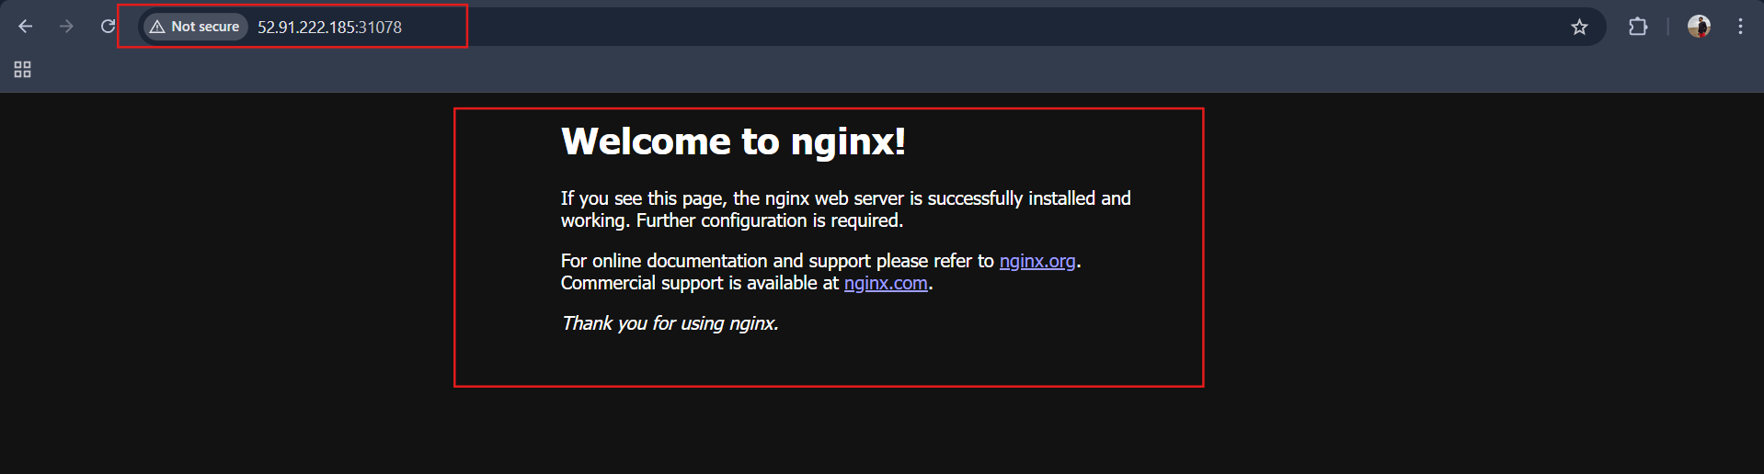
🔹 Step 3: Create test namespace + Pod
kubectl create namespace test
kubectl run testpod --image=busybox -n test -- sleep 3600
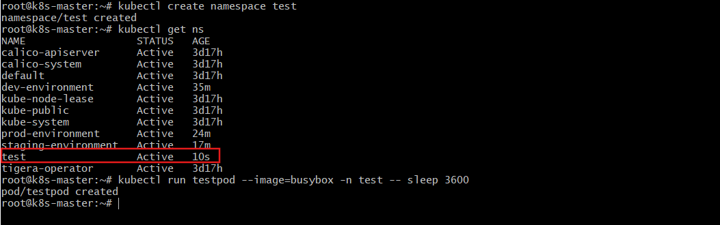
Step 4: Test DNS communication
Exec into test pod:
kubectl exec -it testpod -n test -- sh
Inside container:
wget http://webpod.default
Explanation
Kubernetes DNS format:
<service-name>.<namespace>.svc.cluster.local
Even across namespaces, services are reachable using full DNS.
NodePort → exposes externally
ClusterIP → internal communication

- Apply a LimitRange with a max limit/request ratio of 2 for memory in the performance-environment namespace, and test by creating a pod with mismatched resource requests and limits.
LimitRange with max limit/request ratio in performance-environment
Requirement:
- Max memory limit/request ratio = 2

Step 1: Create Namespace
kubectl create namespace performance-environment
kubectl get ns
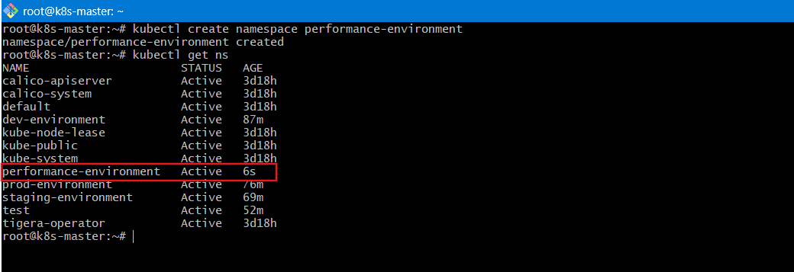

Step 2: Create LimitRange
vi ratio-limit.yaml
apiVersion: v1
kind: LimitRange
metadata:
name: memory-ratio-limit
namespace: performance-environment
spec:
limits:
- type: Container
maxLimitRequestRatio:
memory: "2"
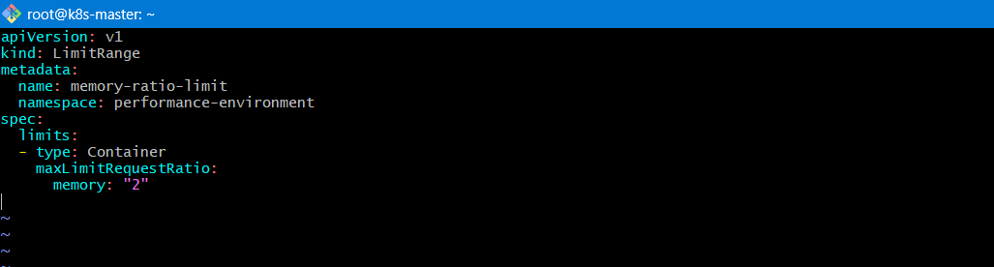
Apply:
kubectl apply -f ratio-limit.yaml
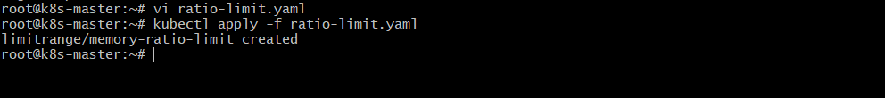
Step 3: Create Violating Pod
vi badpod.yaml
apiVersion: v1
kind: Pod
metadata:
name: bad-pod
namespace: performance-environment
spec:
containers:
- name: nginx
image: nginx
resources:
requests:
memory: "200Mi"
limits:
memory: "600Mi"
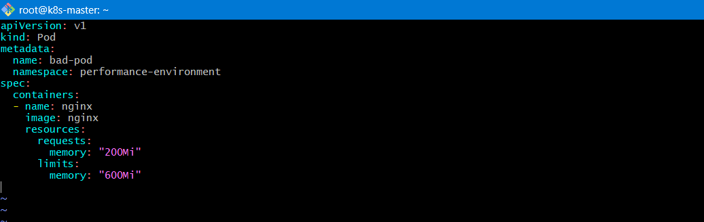
Apply:
kubectl apply -f badpod.yaml
Validation
You should get error like:
limit/request ratio for memory is too high
Now create valid pod:
Request = 200Mi
Limit = 400Mi ✅ (ratio = 2)
Explanation
maxLimitRequestRatio ensures:
limit <= request × ratio
This prevents:
- Huge burstable memory
- Node instability
- Noisy neighbor problems

